chp 3: organizational culture and Environment

chp 4: managing in global environment

chp 5: Social responsibility and managerial ethics

chp 6: Decision Making: The essence of managers job

chp 8: Strategic management

chp 10: Organizational structure

chp 13: Managing change and Innovation

chp 16: Motivating Employees

Frederick W. Taylor, known as the “father” of scientific management

Fayol believed that the functions of management were common to all business endeavors but also were distinct from other business functions.

Weber described an ideal type of organization he called a bureaucracy.

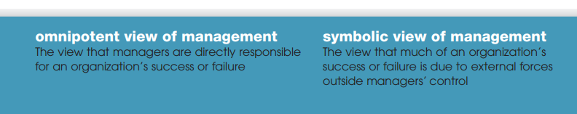

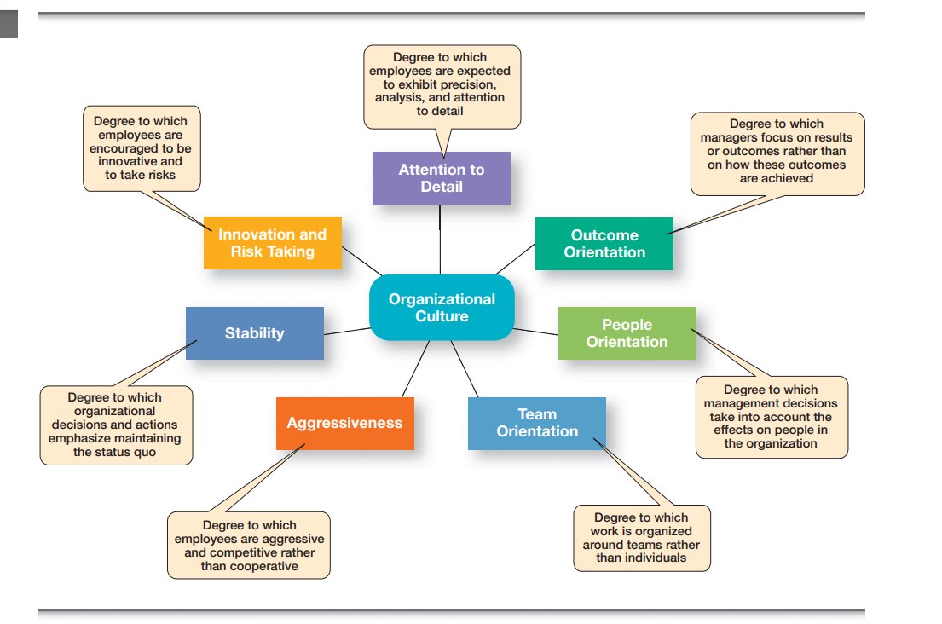

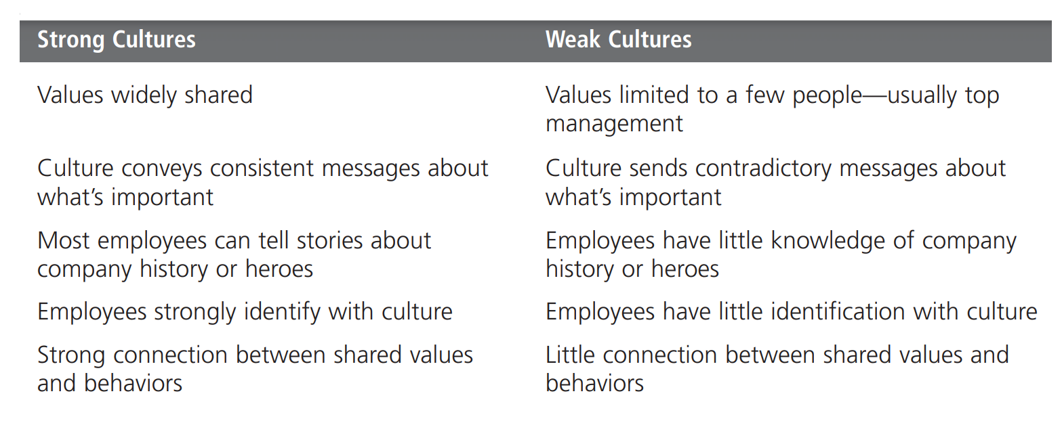

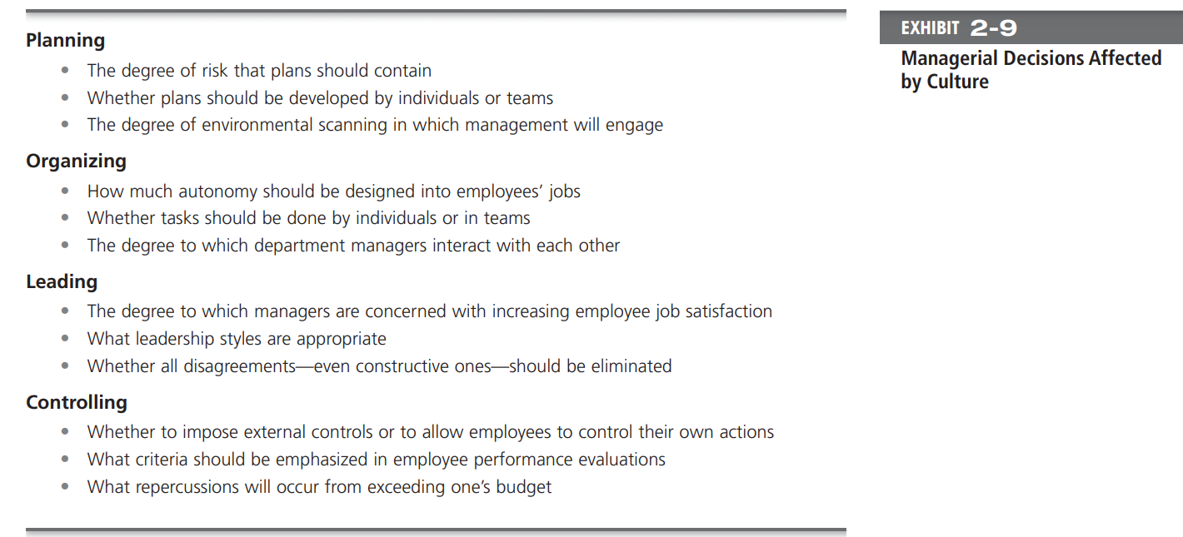

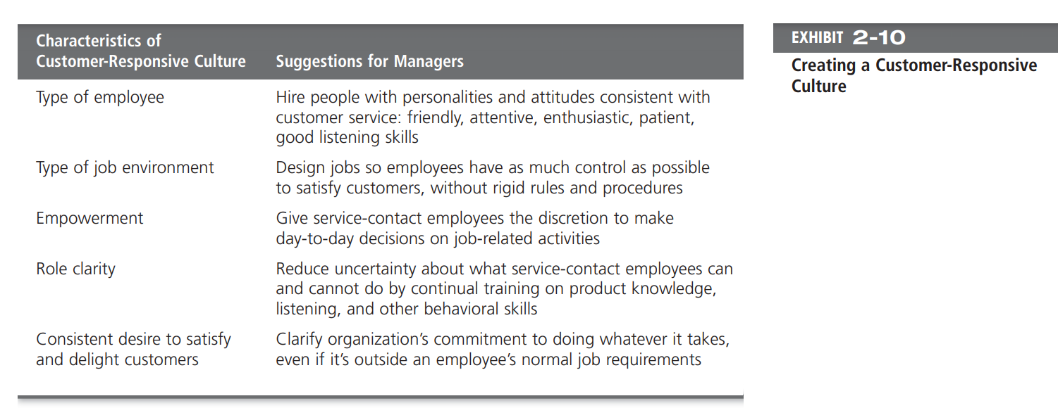

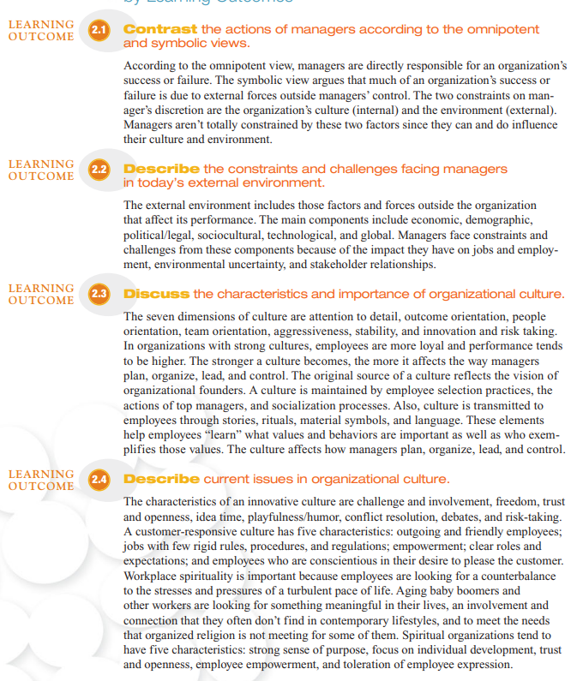

**MANAGERIAL ISSUES**

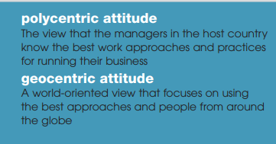

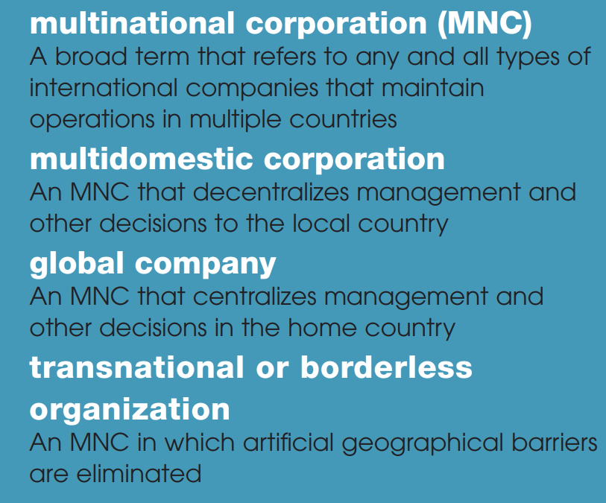

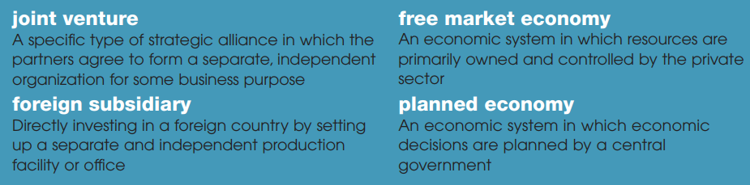

HOFSTEDE’s 5 dimensions:

